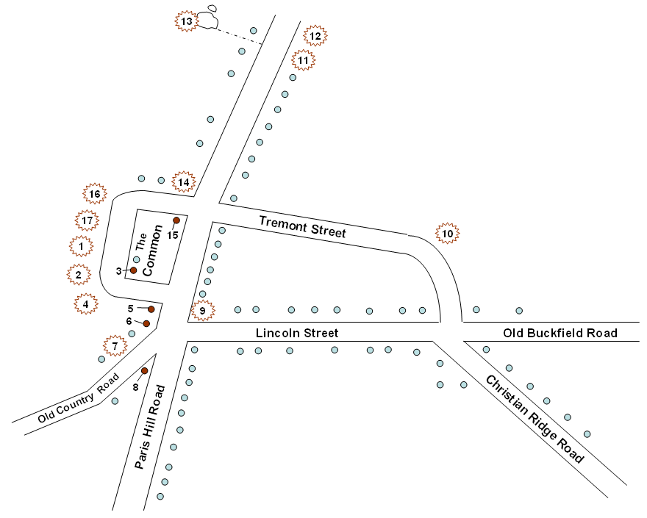
Paris Hill
Village
A Walking Tour of Paris History.
- Old Oxford County Jail
- Jailer’s House
- The Registry
- Oxford County Court House
- “Cross Roads”
- The Old Printing Office
- Paris Hill Academy
- Persis Sibley Andrews Black House

- The Crocker House
- Paris Manufacturing Company Site
- Lemuel Jackson House
- “Old Brick”
- Pioneer Cemetery
- “Lyonsden”
- First Baptist Church of Paris
- “Williscroft”
- Dr. Cyrus Hamlin House

Paris Hill Tour Stops:
Details for the Tour Map of Paris Hill:

- Old Oxford County Jail: built in 1822; used as a jail through 1895.
- Jailer’s House: built 1822; wife prepared prisoners’ meals.
- The Registry: built 1826; storage of wills and deeds and other court papers.
- Oxford County Court House: built 1815, Oxford County Court – Paris was the Shire Town; cannon on lawn, German mortar WWI.
- “Cross Roads”: built 1814; Judge Stephen Emery House; Hannibal Hamlin was married twice here, both daughters of Judge Emery.
- The Old Printing Office: built 1815; several newspapers published here – One of earliest, 1827, The Jeffersonian started by Han. Hamlin, age 18, and friend Horatio King; Soon after that, under different management, the Oxford Democrat was published until late 1890’s, then moved down to S. Paris, and by 1933 had merged with the Norway Advertiser. (*)
- Paris Hill Academy: built 1856; operated as secondary school until 1901. Excellent stage and acoustics on the second floor, and used currently by local community theatre group; building maintained by Paris Hill Community Club. (*)
- Persis Sibley Andrews Black House: built in 1830’s; Persis came to live here on her second marriage in 1855. She kept a well written and fascinating diary account of life in early Paris, excerpts of which are in the Hamlin Library. (*)
- The Crocker House: built 1807 by Thomas Crocker, early political figure, state as well as local; portrait at Hamlin Library.
- Paris Manufacturing Company Site: this house built on the site of several early Paris businesses, including PMfgCo 1869-1883 (then moved to S. Paris); best known for sleds, but many fine examples of furniture around – some at Hamlin Library. (*)
- Lemuel Jackson House: built 1789 by the man noted as the town’s first settler; said to be first frame house built on the Hill.
- “Old Brick”: built 1813 by Capt. Samuel Rawson, bricks made on site; later owned by Kimball family that included very notable military and political figures; NOTE: 3rd floor windows designed smaller to make the whole house appear taller.
- Pioneer Cemetery: burial plot for many of the earliest town settlers.(e.g. Lemuel Jackson) (*)
- “Lyonsden”: built 1807 by Jesse Cummings; late 1890’s to Admiral Harry Lyons, later his son Capt. Harry Lyons, navigating officer of airplane on first trans-Pacific flight to Austrailia in 1928. (*)
- First Baptist Church of Paris: first structure 1803, present structure completed 1838; bell cast in Paul Revere Foundary by Paul’s son, 1821; clock gift of family of Hannibal Hamlin in 1883.
- “Williscroft”: built in 1810 by Deacon John Willis and his wife, daughter of Lemuel Jackson (above); later summer home of Emily Bissell, founder of the Christmas Seal program. (*)
- Dr. Cyrus Hamlin House: built 1806 as simple but elegant farm house by father of Hannibal; Hannibal Hamlin, Vice President under Abraham Lincoln born and grew up here, (then law practice in Hampden, and buried near there); After 1860 Chase Family and then Atwood family, when fancier architectural details were added. (See early photographs at Hamlin Library). (*)

(*) means specific additional information at Hamlin Memorial Library and Museum

